**Market Analysis in Banking Domain**

DESCRIPTION

**Background and Objective:**

Your client, a Portuguese banking institution, ran a marketing campaign to convince potential customers to invest in a bank term deposit scheme.   
The marketing campaigns were based on phone calls. Often, the same customer was contacted more than once through phone, in order to assess if they would want to subscribe to the bank term deposit or not. You have to perform the marketing analysis of the data generated by this campaign.

**Analysis tasks to be done-:**

1. Load data and create a Spark data frame

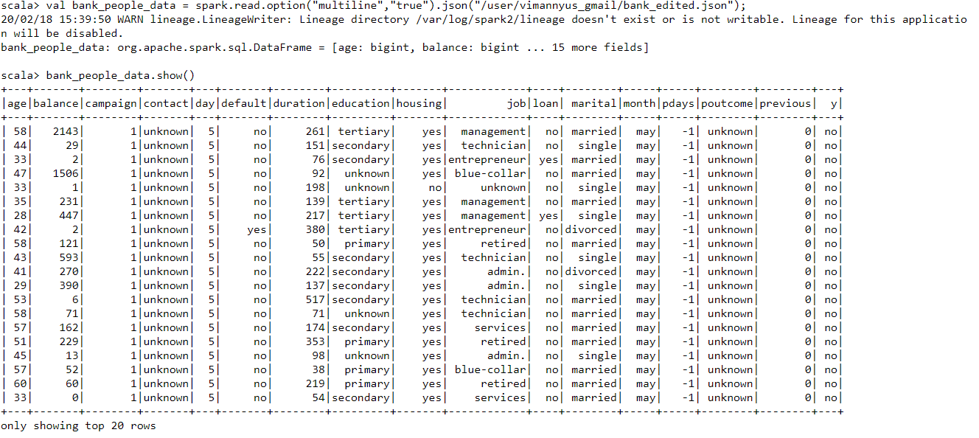

Give the maximum, mean, and minimum age of the average targeted customer.

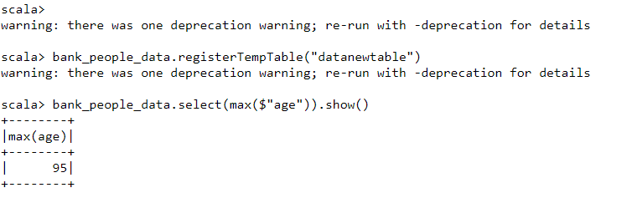

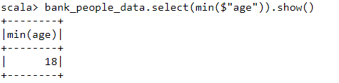

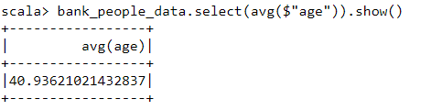

1. **Check the quality of customers by checking average balance, median balance of customers.**

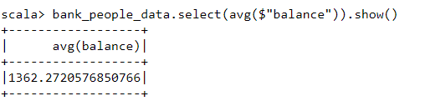

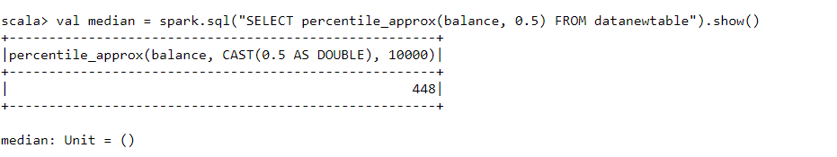

1. **Check if age matters in marketing subscription for deposit.**

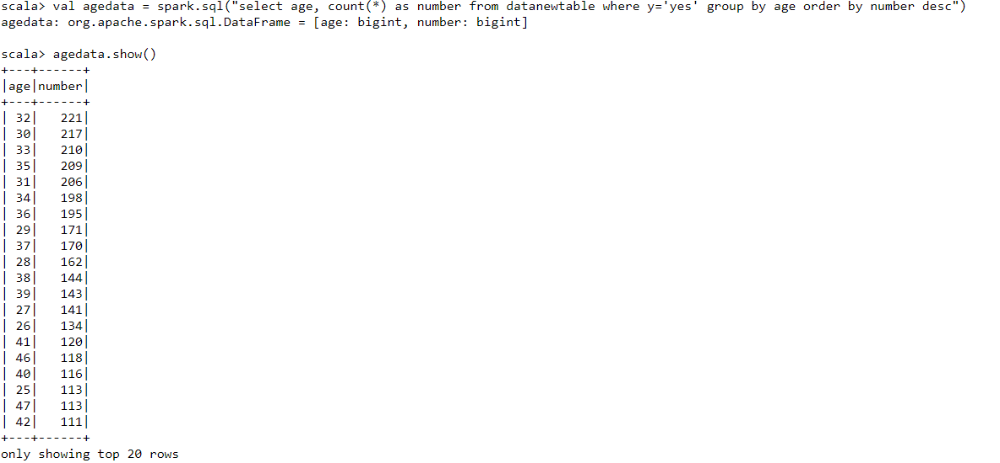

**Check if marital status mattered for a subscription to deposit.**

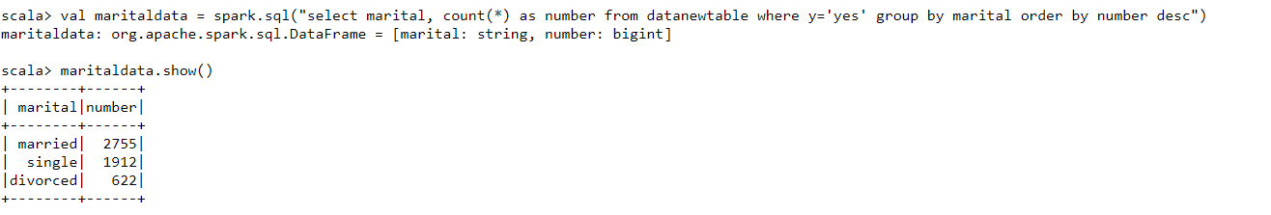

**Check if age and marital status together mattered for a subscription to deposit scheme.**

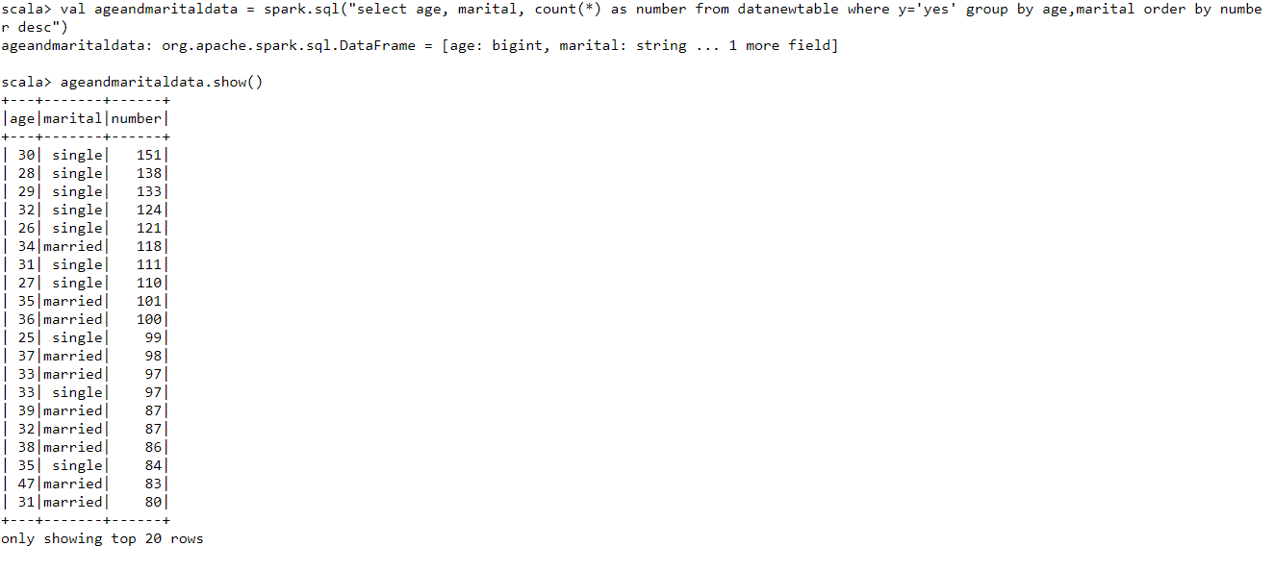

**Do feature engineering for the bank and find the right age effect on the campaign**.

